IB Lang & Lit HL Essay
Content Sections
Line of Inquiry

Thesis Statement

Evidence and Analysis

Writing Textual Analysis Essays

Lang & Lit Academic Essay Conventions

Essay Composition Master Checklist: Formatting and Content

Subject Reports & IB’s 10 Tips

IB Assessment Criteria - Draft Checklist

Literary or Non-Literary [Body of] Work: Author and Genre

Line of Inquiry

What makes a line of inquiry suitable?
- The line of inquiry explicitly indicates a writer making conscious choices about how to construct a work, with an examination of how those choices generate meaning and lead to an informed reading. | B. The line of inquiry incorporates contextual elements, but approaches them from a literary or linguistic perspective.
Not: Transformation in Hamlet  *Refers to the central concepts of the course but is too broad; not specific enough.  Instead: How does Shakespeare use internal and external conflict in Hamlet to propel the title character’s loss of identity? | Not: How does Big Brother in 1984 illustrate the dangers of totalitarianism?  *The focus of the line of inquiry is sociological or political in nature.  Instead: Through what means does George Orwell’s representation of Winston and Julia’s relationship exemplify the dehumanization imposed by the surveillance state in 1984?

Experimenting with Concept-based Inquiry for Inspiration
Rewrite your line of inquiry question as a question based on one of the seven concepts below. Then, rewrite your line of inquiry again using a different concept. You can use the bolded phrases in each example question to build your own, or use your understanding or interpretation of the concept as inspiration.
- Identity—how does Ralph Ellison, in his novel Invisible Man, succeed in making his narrator a convincing spokesperson for the concerns of African-Americans in the 20th century?
- Culture—how does Robert Capa represent post-Second World War France to qualify/exemplify the brutalities of the French population on former Nazi collaborators in La Femme Tondue?
- Creativity—how do Mario Testino’s portraits manage to convey the personalities of those portrayed in original ways?
- Communication—which view of love does Matt Groening convey in Love is Hell?
- Transformation—in what ways does The Alan Parsons Project’s Tales of Mystery and Imagination offer a transformative re-reading of Edgar Allan Poe’s tales?
- Perspective—how does Mary Shelley’s protagonist in Frankenstein use the motif of dangerous knowledge to show the perspective of fear and anxiety of excesses in scientific enterprise in early 19th century Europe?
- Representation—through what means does Juan Rulfo successfully convey the representation of realistic and non-realistic characters and situations in Pedro Páramo?
*Example lines of inquiry from IB teacher support material

Extracting Phrases from IB’s Concept-Based Examples
- How do[es] / To what extent do[es] / In what ways do[es] / Through what means do[es] / Which view of ___ does
Identify author (+genre + [body of] work)

- succeed in making / represent / [manage to/successfully] convey / offer a / use

- a convincing _____ for / [to] qualify / [to] exemplify / [to] show the ____ of / [to] explore / [to] indicate / [to] challenge

Thesis Statement
Reformulates line of inquiry as a statement identifying specific textual features and the persuasive, significant interpretation they invite or support

Line of Inquiry to Thesis Statement: Active verb-ing
In his/her [(body of) work A], Creator/Author
~-verbs that describe authorial choices/craft-~
uses, represents, arranges, structures, composes, manipulates, characterizes, caricatures, reimagines, rereads, portrays, depicts, presents, conveys, offers
[this/these element, theme, dimension, formal quality of the text(s)…,]
in order to
~-verbs that describe meaningful effects or interpretive readings-~
challenge, qualify, exemplify, show, explore, defy, expose, critique, advance, question, indicate, simulate, dissimulate, argue, reveal, transform, counter, oppose, invite, galvanize, alert, satirize/parody, support
interpretation X / X kind of reading.

A PERSUASIVE INTERPRETATION requires candidates to select, analyze, and comment on SPECIFIC FEATURES of the work which relate to and support the chosen line of inquiry.

Specific features => evidence in the text

Evidence and Analysis

Areas of exploration  and features for textual analysis | Text-type / Medium | Reference and citation
Areas of exploration  and features for textual analysis | Literary texts
Areas of Exploration:  - Readers, Writers, and Texts  - Time and space  - Intertextuality  Using Aristotle’s 4 causes to discuss specific features that contribute to overall meaningful effects  - Formal: form, genre, composition; the form the shape or matter enters; design  - Material: the subject material or matter; ‘that out of which’ it is made  - Words, diction  - Efficient: the effect that brings about the finished result; preceding force that pushes it into existence; technique  - Final: the end; what it exists for the sake of  Formal features of literary and non-literary works  Genre conventions - the recognizable signs that tell you what kind or type of art it is; the expectations we have based on what is typical for that genre of art  Structure - the parts of a work and the relationships between/among them  Composition - arrangement of component parts in a whole; the arrangement of beginning, middle, and end  Material features  Material: the subject material or matter; ‘that out of which’ it is made  What it’s made of - physical form and medium/media - verbal, visual, audio  Where and when it’s published / how it circulates - serial, episodic, print, collection, public art / outdoors  Efficient features  Efficient: the effect that brings about the finished result; preceding force that pushes it into existence; technique  Authorial choices, literary techniques, artistic techniques, design techniques  Final features  Final: the end; what it exists for the sake of  What is its purpose as a work of art?  What was the work’s public reception when published or circulated? Would the work’s reception differ in our current context? | Literary fiction / writing  Genre: novel, novella  Literary period or movement:  Language and country of origin: | Quotations:  Embed quotations “like this” (Last-name #).  Works Cited:  Last-name, First-name. Title of Book/Collection. Translated by First-name Last-name, Publisher, Year.
 | Play / written for performance  Body of work:  Genre and literary period: | Quotations:  Quote lines from Shakespeare “like so” (1.2.3-4).  ^The in-text citation above refers to act 1, scene 2, lines 3-4.  Works Cited:  Shakespeare, William. Hamlet. Collection/Anthology Title, edited by Editor-first-name Last-name, Publisher, Year, Page range.  Quote Chekov’s Uncle Vanya “like this instead” (Chekov #).  ^Use page number(s) instead of act and line numbers.  Works Cited:  Chekov, Anton. Uncle Vanya. Translated by First-Name Last-Name, edited by First-Name Last-Name, Publisher, Year.
 | Song Lyrics / written for musical performance  Body of work:  Musical genre and tradition: | Quotations:  Quote phrases from song lyrics “like this” (Last-Name 0:55-1:01).  ^Include the timestamp for when the referenced lyrics are heard in the song.  To quote a set of lines from the lyrics,  “Indent the lines,  Include line breaks” (Last-Name 2:30-55).  Works Cited:  Author Last name, First name. “Song Title.” Album Name. Distributor, Year. Transcript of lyrics.
 | “Non-literary” texts
 | Political Cartoons / drawn and printed  Publisher and location (and/or syndicated?):  Date and immediacy: | Embed image in text:  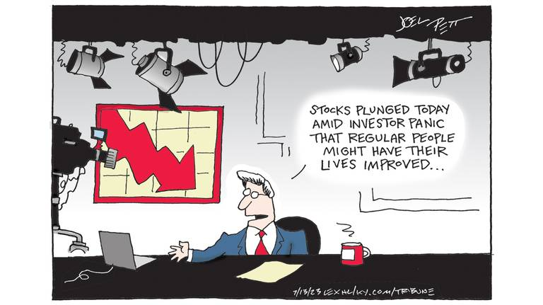  (Pett, “Wall Street v. Main Street”)  Works Cited:  Pett, Joel. “Wall Street v. Main Street.” Lexington Herald-Leader, 12 Jul 2023, www.kentucky.com/opinion/editorial-cartoons/joel-pett/. Accessed 18 Oct 2023.  Last-name, First-name. "Title if Any." Publication Name, date of publication, page number or URL if online.Accessed date.
 | Photography / digital photo images and prints  Photographic medium:  Publisher/Commission: | Embed image in text:    (Hussey, “The Soldier”)  Works Cited:  Hussey, Tom. “The Soldier.” Reflections, Hussey Photography, 2013, www.tomhussey.com/STORIES/REFLECTIONS/2. Accessed 18 Oct 2023.  Last-name, First-name. “Title of the Picture.” Story, Title of the Site, Date, URL. Accessed Date.
 | Painting (Portraiture) / oil on canvas | Embed image in text:    (Wiley, “President Barack Obama”)  Wiley, Kehinde. “President Barack Obama.” 2018, National Portrait Gallery, Washington, D.C., npg.si.edu/Barack_Obama. Accessed 18 Oct 2023.  Artist's Last Name, First Name. Title of Artwork. Date Artwork Created, Name of Institution or Private Collection Housing Artwork, City Where it is Housed.
 | Blog / travel narrative writing and digital photo images | Quotations:  Quote from the blog “like this” (Clarke, “Shortened Title”).  Embed image in text:    (Clarke, “Why Visit Sicily?”)  Works Cited:  Clarke, Daniel James. “Why Visit Sicily? 10 Reasons to Love Italy’s Largest Island.” Dan Flying Solo, 28 Sep 2023, www.danflyingsolo.com/why-visit-sicily-reasons/. Accessed 18 Oct 2023.  Last-name, First-name. "Title of Blog Post." Name of Blog, Blog Network/Publisher if given, date of post, URL. Accessed date.
 | Podcast / recorded audio | Quotations:  Quote from the podcast “like this” (“Title of Episode” 0:00)  ^Include timestamp for the quotation or referenced audio.  Works Cited:  Mahnke, Aaron, host and producer. “Title of the Episode.” Lore, season, episode, Sponsor, Date, URL. Accessed Date.

Writing Textual Analysis Essays

Lang & Lit Academic Essay Conventions
(adapted from Harvard Writing Center’s Brief Guide to Writing the English Paper, p. 6)

- Avoid plot summary. An essay that recounts what happened in a narrative work–or that analyzes selected scenes in the same order they occur in the work–is letting the novel’s author rather than the essay’s author structure the paper’s argument. Instead, you can focus on selected scenes, briefly identifying them before analyzing significant details. Resist shadowing the narrative’s/work’s chronology in your own paper. One rule of thumb is to begin with the most obvious piece of evidence and move progressively to the least obvious piece of evidence.

- Avoid basing your argument on opinion. Sometimes works provoke personal feelings and opinions in a reader/audience. When this happens, the reader should try to suspend those personal feelings and opinions as they close read, paying attention instead to structures and features in the text. Textual evidence and not personal conviction should be the basis of your thesis and argument.
These works don’t tell you what to feel or think; they show or provoke feelings and lines of thought. Look for the authorial choice / textual feature, technique, device, language, form, etc., that provokes or models the thoughts and feelings as effects on the reader.

- Distinguish between “speakers” and authors. Because English papers make claims about texts rather than about authors, poems and narratives have a “speaker” or “narrator” who should not be confused with the author. David Copperfield, while he has autobiographical features, is not Charles Dickens himself.

- Write in the present tense. Because English papers approach literary works as linguistic artifacts rather than as historical documents, they discuss characters and events in the present tense rather than the past tense. For example, one might write: “In The Stranger, Mersault expresses disdain for the conventional concerns of those around him.”

- Use MLA style citations. Because English papers quote frequently, often from the same text, they cite page numbers parenthetically. For example: In The Stranger, Mersault expresses disdain for conventional social expectations and instead ultimately opens himself “to the gentle indifference of the world” (122).

Transitional Words and Phrases

Transitional language is important for clearly presenting complex  ideas by ensuring readers understand the logical connections and  reasoning that join each part of the composition in a meaningful sequence.  When papers lack transitional words and phrases, they start to read  like “choppy” lists of statements, or a mass of stand-alone paragraphs  about a topic. They might present a lot of different thoughts or  information, but they don’t show how these fit together to advance a  new, richer view of the topic (as proposed in thesis statements).  Improve clarity and cohesion—and avoid the dreaded “lack of flow”—  by using transitional words and phrases to create powerful links  between your ideas and help readers understand the paper’s logic.  Transitional language guides readers through complex ideas and  arguments by marking where you’re going and how you’re getting  there.  *In addition to improving clarity and cohesion, being purposeful and selective about your transition phrases in and between paragraphs will improve the ACCURACY, INCISIVENESS, and LOGICAL COHERENCE of your interpretive argument and analysis. One of IB examiners’ main criticisms of the HL essays has been the lack of accurate language and coherence of interpretive argument. | Use transitional words and phrases at the sentence- and paragraph-levels in your own writing to…  Build on the preceding text  Addition (of info or emphasis): also, and, in fact, indeed, moreover, in  addition, furthermore, besides X, both X and Y, above all, more/most  importantly  Example: such as, for instance, in particular, notably, consider, specifically,  for example, as an illustration  Clarification: actually, in other words, by extension, ultimately, in short, that  is (to say), namely, more precisely, to put it another way  Similarity: similarly, in like manner, likewise, equally, in the same way, by  the same token  Reference: regarding, considering, the fact that, as for, on the subject of  Contrast or challenge the preceding text  Contrast: but, however, though, equally, by way of contrast, while, on the  other hand, (and) yet, whereas, in contrast, (when) in fact, conversely,  despite, while, nonetheless  Concession: admittedly, granted, of course, although (it is true),  notwithstanding, even so, on the other hand  Dismissal: regardless, whatever the case, all the same  Make a causal connection  Causation/consequence: accordingly, as a result, consequently, thus,  hence, therefore, since, because, for this reason, as a result  Condition: (even) if, (only) when, on the condition that, in the case that,  provided that, in the event, unless, given that, inasmuch as, insofar as,  otherwise, if so  Indicate ordering  Sequence: first, second, third..., to begin, at first, initially, first of all,  subsequently, previously, after, before, next, then, eventually, at last,  finally, lastly, to conclude, as a final point  Retrospection: to return to, to resume, as previously stated/mentioned,  overall, in summary, briefly, given these points, as has been noted, in  sum, altogether, to summarize

Using Strong Verbs in Evidence and Analysis - Quotations
(Source: Gerald Graff and Cathy Birkenstein, They Say/I Say: The Moves that Matter in Academic Writing, 5th ed., W.W. Norton & Co., 2021.)

The following formula and templates refer to embedding quotations from secondary sources, but they are easily adapted to writing about literary works. The two groups of signal words below are excellent for incorporating strong verbs in your sentences!

Embedding quotations in sentences
When quoting a source in your writing, the quotation becomes part of the paragraph in which it
appears. Since paragraphs are made up of sentences, you’ll need to embed the quotation itself in a
sentence of your own making.
Embedding quotations places them in the context of your own writing. To embed a quotation in the
sentence, identify the source and introduce the quotation with a signal word.

Strong Verbs: Common signal words

says (if quoting speech/dialogue) emphasizes claims acknowledges
writes suggests contends reports
states observes argues explains
remarks continues agrees/disagrees urges

Framing quotations in your writing
Frame every quotation to clearly present its relevance and meaning for readers by applying this two-part formula called a “quotation sandwich” (51). As if sandwiching ingredients between two slices of bread, for a “quotation sandwich” you insert the quotation between the introductory statement that introduces and embeds the quotation in the sentence, and a follow-up sentence that explains why the quotation is important and what you understand it to mean.

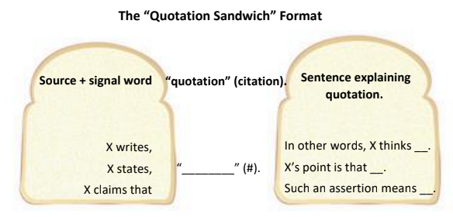

Pro Tip for using the “quotation sandwich” format in your writing

Notice that signal words appear in both sets of templates above. This is because signal words are
descriptive verbs that introduce quotations as well as introducing summaries, explanations, and
redescriptions of what was stated.

You can enhance the clarity, impact, and sophistication of your writing when explaining quotations by
selecting more specific descriptive verbs that appropriately signal what you take the quoted author’s
meaning or purpose to be.

Try this technique when you quote sources in your writing:
- When introducing quotations, focus on presenting information about the source (such as title, topic, genre, author, author’s credentials, etc.) and use a common or neutral signal word, such as the common signal words listed on the first page.
- Then, choose a more specifically expressive, emotionally-charged, and/or value-laden, signal word to introduce and reinforce your explanation of the quotation. The second group of strong verbs below provides a sampling of these more specific and expressive signal words.

Strong Verbs: Specific and Expressive Signal Words
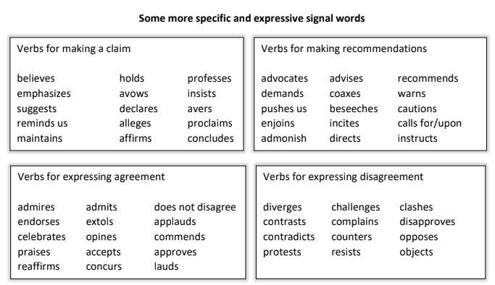

Templates for crafting a “quotation sandwich”: introducing and explaining

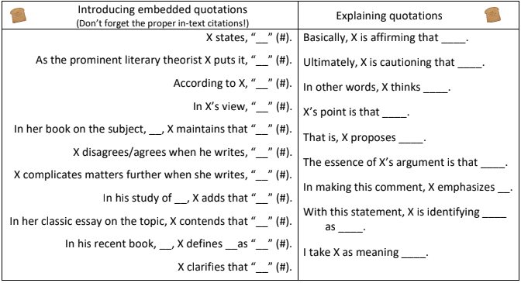

Writing Exercises for Drafting and Revision

- Make a couple more templates for introducing and embedding quotations using the lists of signal words and the formula:
Identify source X + signal word/phrase + “____” (#).

- Make a couple more templates for explaining or summarizing quotations using the lists of more specific and expressive signal words.
For example: By challenging ____, X advances her own view that _____.
In maintaining ______, X confuses _____ and _____.

- Apply the “quotation sandwich” model to the quotations and direct references in your HL essay.

Practice:
1. introducing the source and using signal words to embed the quotation in a sentence with proper punctuation and citation, and
2. following-up with a sentence that explains or summarizes the importance of the quotation and tells readers what you take the meaning to be

Essay Composition Master Checklist: Formatting and Content

Introduction | - Identifies the work or body of work focused upon.  - Establishes line of inquiry that explicitly examines authorial choices and how they generate meaning, or incorporates contextual elements but approaches them from a literary or linguistic perspective.  - Thesis statement clearly indicates the relevant features of the work(s) and the interpretation you will argue and provide evidence for.
Body Paragraphs | - Each body paragraph begins with a topic sentence that establishes the interpretive claim elaborated in the paragraph and the component(s) or feature(s) of the work(s) that you analyze to support it. Interpretive claim connects the line of inquiry to the textual evidence considered.  - Each paragraph provides textual evidence for a particular claim, including quotation(s), references to specific features of the work or specific repeated or related features across a body of work.  - Each paragraph ends with a transitional sentence that links the interpretive claim of that paragraph to the topic, claim, or focus of the next–that is, connects the interpretation to its meaning as part in relation to other parts in the context of the whole. (Or, a transitional phrase at the beginning of the next paragraph’s topic sentence provides the link.)
References / Textual Evidence | - Every quotation is embedded in a sentence that integrates or flows smoothly with the surrounding sentences. No isolated quotations.  - Every quotation from, paraphrase of, or direct reference to the work(s) includes a parenthetical citation before the period of the sentence.  - If writing about a graphic novel, TV show, advertisement, film, etc., then embed the relevant panels/texts/stills being analyzed within the body of the essay.  - Hyperlinks won’t work in examiners’ copies, so either include the linked work(s) in an appendix or provide clear and complete reference information to allow the examiner to access the material.  - Works Cited page with complete citations for all work(s) referred to or written about.
Conclusion | - Answers the Line of Inquiry by proposing a significant, persuasive re-/interpretation of the work(s) as a whole.  - States how that significant interpretation emerges as the culminating implication of the sustained analysis you developed, completing your essay’s line of inquiry.
Sentence-level | - Purposeful and accurate transitional phrases between sentences and paragraphs.  - Strong verbs  - Read essay aloud to check for errors or awkward moments in grammar and sentence structure.
Format | - Title Page [Double-check with your teacher for final formatting guidance]  English A: Language and Literature  Literary/Non Literary Body of Work: [Text Type] by [Author]  Higher Level Essay  Line of Inquiry: [“...?”]  Word Count: [####]

Subject Reports & IB’s 10 Tips

May 2023 Subject Report

May 2022 Subject Report

Nov 2021 Subject Report

IB’s 10 Tips for the HL Essay

IB Assessment Criteria - Draft Checklist

Criterion A: Knowledge, understanding, and interpretation / 5 marks
- How well does the candidate demonstrate knowledge and understanding of the work or body of work chosen?
- To what extent does the candidate make use of knowledge and understanding of the work or body of work to draw conclusions in relation to the chosen line of inquiry?
- How well are ideas supported by references to the work or body of work in relation to the chosen line of inquiry?

- Troubleshoot your line of inquiry and thesis statement to make sure they center authorial choices and/or textual features, rather than focusing foremost on sociological, psychological, historical, political, or philosophical topics.
Criterion B: Analysis and evaluation / 5 marks
- To what extent does the candidate analyse and evaluate how the choices of language, technique and style, and broader authorial choices shape meaning in relation to the chosen line of inquiry?

“It is not enough to simply identify a specific feature without discussing the effects created.” - Subject Report Nov 2021

- Make sure your essay includes and explores relevant techniques in your chosen text type.
Criterion C: Focus, organization, and development / 5 marks
- How well organized, focused and developed is the presentation of ideas in the essay?
- How well are examples integrated into the essay?

- Reverse outline to refine your draft essay structure and organization (links to Vanderbilt professor’s reverse outline handout).
- Reverse outline quick-check:
Copy and paste your essay into a new document.
Bold the first and last sentences of each body paragraph.
  - Is the first sentence of each paragraph a topic sentence that identifies the main claim that paragraph makes in response to your line of inquiry and identifies the particular textual feature(s) you use as supporting evidence?
  - Does the last sentence (or sentences) of each paragraph relate its main claim or idea to the significant interpretation you propose in your thesis?
  - Does each paragraph contain direct reference to textual features that support your main claim or idea? Did you include parenthetical citations for each direct reference to the text(s)? Did you embed all quotations in your own sentences?
  - Are there links between the paragraphs? Look at the last sentence of each body paragraph and the first sentence of the following paragraph – one of them should contain a transitional phrase that links the two.
  - Consider possible changes in your paragraph ordering. Would it improve your interpretive argument if you put the paragraph with the most obvious evidence first and proceed to the least obvious? Would rearranging your paragraphs develop your interpretive argument more persuasively?
Criterion D: Language / 5 marks
- How clear, varied and accurate is the language?
- How appropriate is the choice of register and style? (“Register” refers, in this context, to the candidate’s use of elements such as vocabulary, tone, sentence structure and terminology appropriate to the HL essay).

- Replace “to be” verbs and vague or repeated verbs with purposefully chosen strong verbs.
- Read drafts and revised paper aloud to catch mistakes and awkward phrasing.

PhraseBook for Writing Papers and Research in English (PDF found online; hard copies also in the Writing Lab)

University of Manchester Academic Phrasebank

Purdue Online Writing Lab on Paragraphing
https://owl.purdue.edu/owl/general_writing/academic_writing/paragraphs_and_paragraphing/index.html

The Basic Rule: Keep one idea to one paragraph
The basic rule of thumb with paragraphing is to keep one idea to one paragraph. If you begin to transition into a new idea, it belongs in a new paragraph. There are some simple ways to tell if you are on the same topic or a new one. You can have one idea and several bits of supporting evidence within a single paragraph. You can also have several points in a single paragraph as long as they relate to the overall topic of the paragraph. If the single points start to get long, then perhaps elaborating on each of them and placing them in their own paragraphs is the route to go.

Elements of a paragraph
To be as effective as possible, a paragraph should contain each of the following: Unity, Coherence, A Topic Sentence, and Adequate Development. As you will see, all of these traits overlap. Using and adapting them to your individual purposes will help you construct effective paragraphs.

UNITY
The entire paragraph should concern itself with a single focus. If it begins with one focus or major point of discussion, it should not end with another or wander within different ideas.

COHERENCE
Coherence is the trait that makes the paragraph easily understandable to a reader. You can help create coherence in your paragraphs by creating logical bridges and verbal bridges.
Logical bridges
- The same idea of a topic is carried over from sentence to sentence
- Successive sentences can be constructed in parallel form
Verbal bridges
- Key words can be repeated in several sentences
- Synonymous words can be repeated in several sentences
- Pronouns can refer to nouns in previous sentences
- Transition words can be used to link ideas from different sentences

A TOPIC SENTENCE
A topic sentence is a sentence that indicates in a general way what idea or thesis the paragraph is going to deal with. Although not all paragraphs have clear-cut topic sentences, and despite the fact that topic sentences can occur anywhere in the paragraph (as the first sentence, the last sentence, or somewhere in the middle), an easy way to make sure your reader understands the topic of the paragraph is to put your topic sentence near the beginning of the paragraph. (This is a good general rule for less experienced writers, although it is not the only way to do it). Regardless of whether you include an explicit topic sentence or not, you should be able to easily summarize what the paragraph is about.

ADEQUATE DEVELOPMENT
The topic (which is introduced by the topic sentence) should be discussed fully and adequately. Again, this varies from paragraph to paragraph, depending on the author's purpose, but writers should be wary of paragraphs that only have two or three sentences. It's a pretty good bet that the paragraph is not fully developed if it is that short.
Some methods to make sure your paragraph is well-developed:
- Use examples and illustrations
- Cite data (facts, statistics, evidence, details, and others)
- Examine testimony (what other people say such as quotes and paraphrases)
- Use an anecdote or story
- Define terms in the paragraph
- Compare and contrast
- Evaluate causes and reasons
- Examine effects and consequences
- Analyze the topic
- Describe the topic
- Offer a chronology of an event (time segments)

How do I know when to start a new paragraph?
You should start a new paragraph when:
- When you begin a new idea or point. New ideas should always start in new paragraphs. If you have an extended idea that spans multiple paragraphs, each new point within that idea should have its own paragraph.
- To contrast information or ideas. Separate paragraphs can serve to contrast sides in a debate, different points in an argument, or any other difference.
- When your readers need a pause. Breaks between paragraphs function as a short "break" for your readers—adding these in will help your writing be more readable. You would create a break if the paragraph becomes too long or the material is complex.
- When you are ending your introduction or starting your conclusion. Your introductory and concluding material should always be in a new paragraph. Many introductions and conclusions have multiple paragraphs depending on their content, length, and the writer's purpose.

Transitions and signposts
Two very important elements of paragraphing are signposts and transitions. Signposts are internal aids to assist readers; they usually consist of several sentences or a paragraph outlining what the article has covered and where the article will be going.
Transitions are usually one or several sentences that "transition" from one idea to the next. Transitions can be used at the end of most paragraphs to help the paragraphs flow one into the next.

